
NARRATIVE:
Narratives need to cover the relevant points of shoplifting or the alleged offence for a prosecution to be considered.
For example, the elements of shoplifting are below:
Did Steal (list of stolen items)
Valued at (dollar value of items confirmed stolen)
The property of (organisation name)
Further points of interest:
- Date, Time, Location
- Number of people involved
- Method of Operation
- Method of transportation

Example Narrative Template:
On (Date & Time) at (address) (number of people) entered (organisation).
The (person/s) (method of operation and items taken)
They exited by (method of exit) making no attempt to pay for the items.
Method of transport (if known)
Additional Information:
- Behaviour
- Any interactions with staff
- Did anyone recognise them

Example Narrative:
At 12:00pm on Wednesday 3rd August 2022 at 123 Fake Street, Papakura, one male entered Countdown.
The male entered the store through the main entrance and placed several packets of meat and body wash into a shopping basket.
The male has put these items into a backpack he was wearing.
The male has exited the store via self-service check out making no attempt to pay for the items. The male walked down Fake Street in the direction of…
The male was seen getting into a grey sedan (make & model), registration FAKE21.

DESCRIPTION
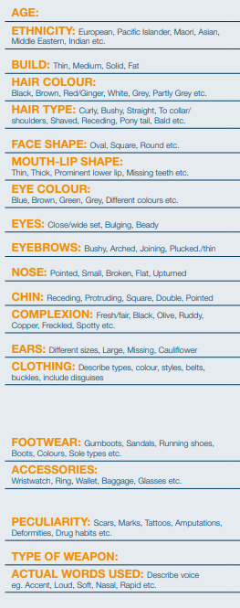
CCTV / PHOTOS
To streamline processes, please ensure footage is saved and uploaded as soon as practicable.
If possible, include one still image of the offender/s.
Staff tasked with uploading footage are considered a witness and need to have their details recorded on the report.

ITEMS STOLEN / PRODUCTS
To satisfy the elements of shoplifting Police need an itemised list of items that have been taken and receipts for those items.
In circumstances where a trolley load of items is stolen, at the bare minimum, we need to know at least some of the items that were in that trolley. Reporting “1x whole trolley of goods” is of no evidential value.

WITNESSES
In most prosecutions statements are required as evidence, therefore it is critical that witnesses are identified in reports.
Please ensure full names of staff involved in the incident and their roles are included as well as up to date contact details.

